Portfolio Designer Tool – Spec Sheet

Purpose: A web tool to help users design and get to us their portfolios of energy buildouts by suggesting modifications to a “template” portfolio.

Goals:

* Simple and user friendly
* Gets us info we need to model their portfolios
* Fast for us to make

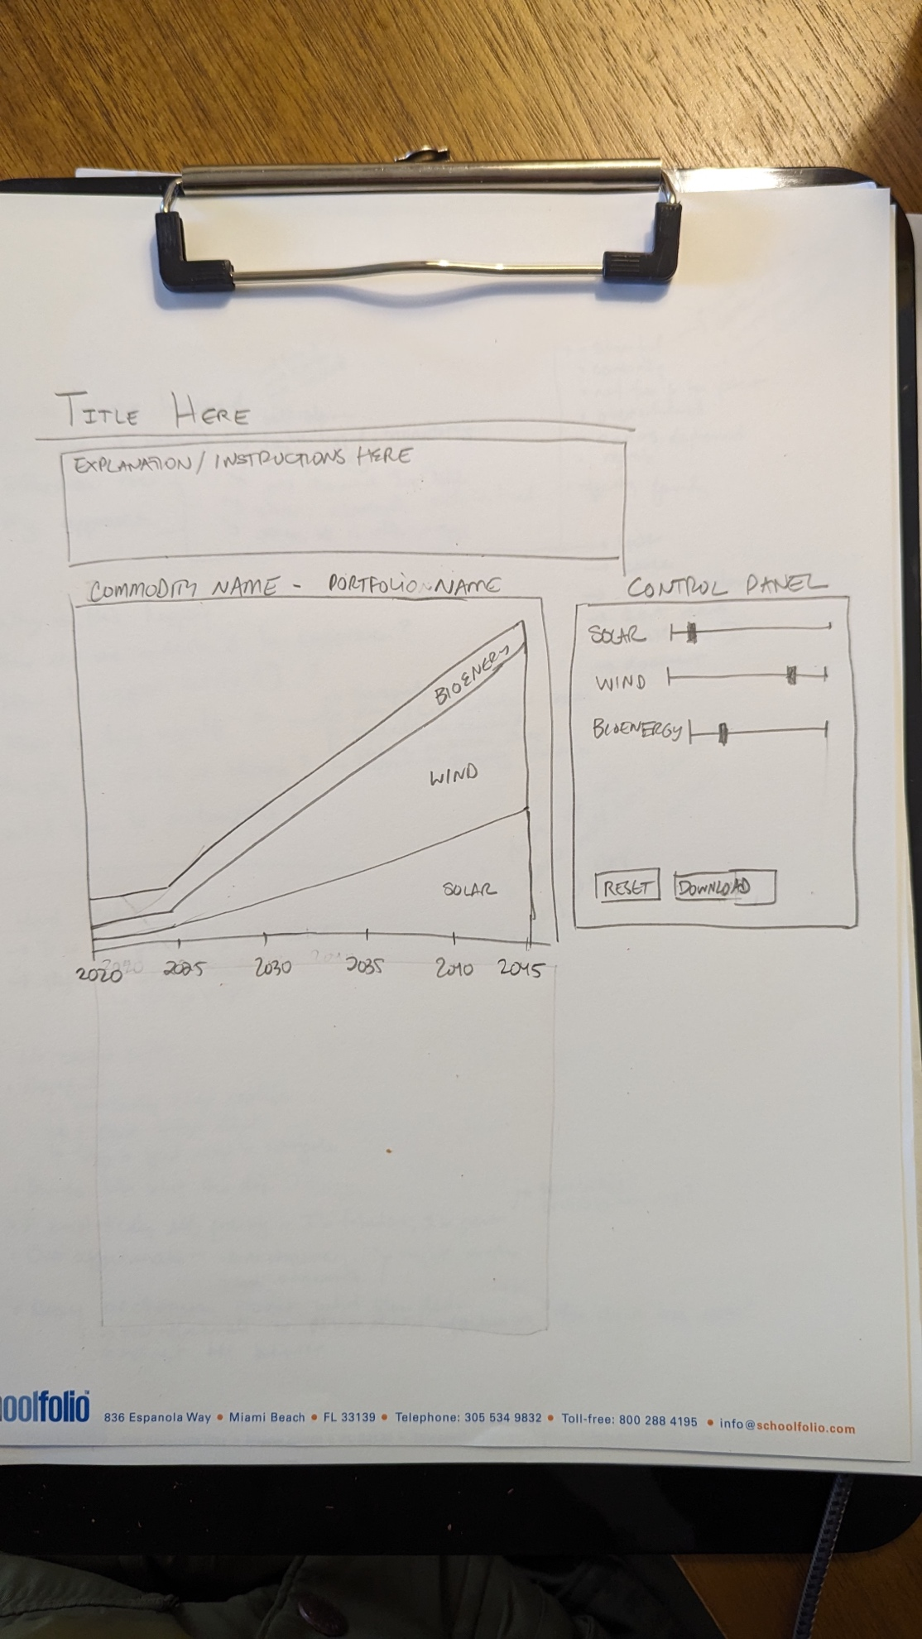

Elements:

* Title: “SJV Portfolio Designer v 0”
* Explanation: a text box explaining what this is and how to use it (I’ll provide text later)
* Main Graph and Controls Option 1:
  + Show an area chart with the buildout over time of how each feedstock contributes to each commodity. Each commodity will have different units (MW for electricity, tons for H2, and MCF of biogas. So we would need 3 different panels, one below the next.
  + The user then uses a slider bar or some other mechanism that moves the size of the bar in 2045, and the tool re-interpolates or scales the visual from 2025 to 2045 accordingly.
  + For hydrogen and biomass, it would be nice to ask the user how should they be used (TBD)
* Main Graph and Controls Option2
  + Have users modify the Sankey somehow, but this seems complicated.
* User can press “reset” to reset the graph to its default portfolio
* Download lets the user download the CSV and email it to us.
* Not shown but just thought of it: a box that lets them name their portfolio however they want